**Assignment-6**

1. What are the various elements of the Excel interface? Describe how they're used.

* Ans. Quick Access Toolbar. This toolbar is located in the upper left corner of the screen. ...
* File Tab. Excel 2007's Office button has been replaced by the File tab. ...
* Title Bar. The title bar of the spreadsheet is at the top of the window. ...
* Control Buttons. ...
* Menu Bar. ...
* Ribbon/Toolbar. ...
* Dialog Box Launcher. ...
* Name box.

1. Write down the various applications of Excel in the industry.

Ans.

* Using Excel For Managing Product Information. ...
* Sales Reporting In Excel. ...
* Stock & Inventory Management Using a Spreadsheet. ...
* Automate Business Tasks With Excel. ...
* Build Excel Dashboards. ...
* Use Excel For Accounting. ...
* Invoice Creation & Tracking In Excel.

1. On the ribbon, make a new tab. Add some different groups, insert commands in the groups and name them according to their commands added. Copy and paste the screenshot of the steps you followed.

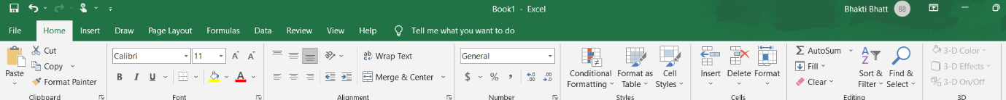

1. Make a list of different shortcut keys that are only connected to formatting with their functions.

Copy: Ctrl + C.

Cut: Ctrl + X.

Paste: Ctrl + V.

Maximize Window: F11 or Windows logo key + Up arrow.

Open Task View: Windows logo key + Tab.

Display and hide the desktop: Windows logo key + D.

Switch between open apps: Alt + Tab.

Open the Quick Link menu: Windows logo key + X

1. What distinguishes Excel from other analytical tools?

Excel can create and customize charts, graphs, tables, and pivot tables to visualize and summarize data, and can integrate with other Microsoft products, such as Word, PowerPoint, and Outlook, as well as import and export data from various sources and formats.

1. Create a table and add a custom header and footer to your table.

Ans.